SMARTLEARN
A Full-Stack Learning System

SAPTHAGIRI NPS UNIVERSITY
Submitted By:
SHREYA S DEVADIGA
(USN: 24SUPMCAGL083)
MCA -AI/ML “B”
Academic Year:
2024 – 2026

JAVA FULL-STACK INTERNSHIP BY TRIPLLAR

Under the Guidance of:
Mr. Gajendra Singh N

CHAPTER NO | DESCRIPTION | PAGE NO
1 | Introduction | 2
2 | Problem Statement | 3
3 | Proposed Solution | 4
4 | Technology Stack | 5
5 | System & Database Design | 6-8
6 | System Workflow | 9-11
7 | Module Description/Results | 12-16
8 | Future Enhancements | 17
9 | Conclusion | 18

Chapter 1
Introduction

In today’s digital era, technology is transforming how students learn, interact, and evaluate their academic progress. Traditional learning systems—while useful—often fail to address the individual needs of students, especially those requiring personalized attention or cognitive support. These platforms generally follow a uniform learning structure that does not adapt to differences in comprehension speed, learning style, or cognitive challenges. As education becomes increasingly digitized, the demand for intelligent, responsive, and inclusive learning environments continues to grow. With the introduction of Artificial Intelligence, new possibilities emerge that enable students to learn smarter, faster, and more effectively.
SmartLearn is an innovative, AI-driven learning and assessment system designed to enhance the educational experience using modern technologies. Beyond the basic features of conventional e-learning platforms, SmartLearn focuses on making education more inclusive, adaptive, and engaging. The platform integrates standard e-learning features with advanced capabilities such as Dyslexia-friendly reading assistance, Emotion Detection, Reward-based learning, and Personalized Progress Tracking. These tools help bridge the gap between standard digital learning and the diverse needs of individual learners, ensuring that every student receives the support they need.
Developed as a full-stack application, SmartLearn provides:
• A clean, interactive interface for students that ensures smooth navigation, improved readability, and a visually engaging presentation of learning materials.
• Secure admin management for learning modules, enabling administrators to efficiently organize content, manage users, and track overall learning activity with complete control and authentication.
• Real-time analysis of learner behaviour, allowing the system to observe patterns in student engagement, performance, and emotional states, and adjust the learning experience accordingly.
The goal of SmartLearn is to promote inclusive education, increase understanding, and encourage active participation by making the learning process adaptive and user-centered. By combining artificial intelligence with a well-designed user experience, SmartLearn creates a supportive digital environment where students not only study content but also feel understood, guided, and motivated. The platform aims to empower learners of all backgrounds by simplifying their educational journey, reducing learning barriers, and offering personalized support that evolves with each student’s progress.

Chapter 2
Problem Statement
Despite advancements in digital education, today’s students face a wide range of learning challenges that limit the effectiveness of existing online learning platforms. These challenges arise across three major areas: educational, technical, and user-centered aspects. Addressing these issues is essential to ensuring that students can learn efficiently, confidently, and without unnecessary barriers.

Educational Challenges
- Lack of personalized learning paths
Most e-learning platforms deliver the same content to all students regardless of their learning speed, prior knowledge, or individual strengths and weaknesses. This uniform approach often results in disengagement and reduced learning efficiency.
- Minimal support for students with learning disabilities such as dyslexia
Traditional digital systems rarely provide accessibility features like dyslexia-friendly fonts, enhanced spacing, or visual reading guides. As a result, neurodiverse learners struggle to read, interpret, and retain content effectively.
Technical Challenges
- Absence of a unified platform for personalization, content delivery, and progress tracking
Existing tools may offer video lessons, quizzes, or progress dashboards separately, but rarely provide a centralized system that combines intelligent personalization, adaptive learning, and real-time analysis in a single interface.
- No real-time insights into student engagement or comprehension
Traditional LMS platforms rely on static data such as test scores or attendance logs, lacking dynamic insights like attention levels, emotional state, or ongoing performance trends.
User Challenges
- Students often lose motivation without feedback or rewards
Learning can become monotonous when users do not receive recognition, encouragement, or rewards. Lack of gamification often results in lower engagement and decreased consistency in studying.

Chapter 3
Proposed Solution
SmartLearn provides a unified and intelligent digital learning environment that integrates e-learning content, real-time analytics, and AI-based cognitive support into one seamless platform. It is designed to overcome the limitations of traditional learning systems by delivering a personalized, accessible, and engaging learning experience for every student.
The system incorporates several advanced features that enhance the effectiveness of digital education. One of the key components is the Dyslexia Mode, which transforms standard text into a more readable format using dyslexia-friendly fonts, improved spacing, and focus-highlighting tools. This ensures that neurodiverse learners can read and comprehend material more comfortably, reducing frustration and enabling equal learning opportunities.
SmartLearn also introduces a Gamified Reward System that boosts motivation and encourages consistent learning habits. Students earn badges, points, and achievement milestones for completing lessons or performing well on assessments. This reward-based structure transforms learning into an enjoyable and goal-driven experience, especially helpful for younger learners or students who need additional motivation.
For administrators and educators, the platform provides a powerful Admin Dashboard with tools to manage users, upload or modify learning modules, track class performance, and monitor individual progress. Detailed analytics help educators identify struggling learners early and provide necessary interventions.
On the other side, the Student Dashboard offers an attractive, interactive interface where learners can access modules, monitor their progress, view earned rewards, and receive personalized recommendations. Visual charts and progress bars make the learning journey clear and easy to follow.
The core goals of SmartLearn are to enhance learning effectiveness through AI, support neurodiverse learners, increase engagement through gamification, and deliver accurate insights through real-time tracking. By bringing together accessibility tools, emotional analysis, learning analytics, and interactive design, SmartLearn bridges the gap between academics and personalized cognitive support. It ultimately delivers an inclusive, adaptive, and student-centered learning experience that aligns with the needs of modern digital education.

Chapter 4
Technology Stack and Decision Rationale

Layer | Technology | Rationale
Frontend | React (Vite) | Modular and high-performance component-based framework
Backend | Spring Boot | Secure and scalable REST API framework
Database | MySQL | Reliable and easy to integrate with Spring
Authentication | JWT | Ensures secure session management
Charts | Recharts | Interactive and responsive visualization library
Styling | CSS3 + Responsive Layout | Ensures modern and adaptive design
These technologies were chosen to create a responsive, efficient, and user-focused application that supports scalability and performance.

Chapter 5
Database Design
The SmartLearn system uses a MySQL database with a well-structured and normalized schema that ensures high reliability, scalability, and efficient management of learning-related data. The database is designed to store and organize all essential information related to users, learning modules, emotions, rewards, and progress tracking, with each table connected through clear relational mapping.
Database Schema Overview
Table | Purpose
users | Stores student/admin details and login credentials
assignments | Manages assignment records for each student
results | Stores exam results, marks, and subject details
attendance | Tracks student attendance with date-wise entries

Schema Structure (SQL)
CREATE DATABASE IF NOT EXISTS smartLearn;
USE SmartLearn;

-- USERS
CREATE TABLE users (
id BIGINT AUTO_INCREMENT PRIMARY KEY,
email VARCHAR(150) NOT NULL UNIQUE,
fullname VARCHAR(150) NOT NULL,
password_hash VARCHAR(255) NOT NULL,
username VARCHAR(100) NOT NULL,
role VARCHAR(20) NOT NULL
);

-- Rewords
CREATE TABLE dyslexia_rewards (
id INT AUTO_INCREMENT PRIMARY KEY,
user_id BIGINT NOT NULL,
lessons_completed INT DEFAULT 0,
reward_points INT DEFAULT 0,
updated_at TIMESTAMP DEFAULT CURRENT_TIMESTAMP ON UPDATE CURRENT_TIMESTAMP,
FOREIGN KEY (user_id) REFERENCES users(id)
);

Relationships
- One User → Many Rewards
- One User → Many Progress Records
Each Rewards, lesson belongs to one Student (user)
This relational design ensures proper data integrity and smooth retrieval for analytics and dashboards.
Key Characteristics
- Each Record, Reward Entry, and Progress Log is linked to one User.
- This design ensures correct data mapping and easy retrieval for dashboards.
- Maintains referential integrity using foreign keys.
- Normalized tables help avoid duplication of data.
- Supports secure multi-user access for admins and students.
- Optimized for analytics progress tracking, and rewards.
- Scalable to handle more users and modules.

Chapter 6
System Workflow

The SmartLearn platform follows a smooth, secure, and fully integrated full-stack workflow that ensures accurate data flow between the frontend, backend, and database. Every layer—UI, APIs, AI components, and database—works together seamlessly to deliver an intelligent and personalized learning experience for both students and administrators.

Frontend Layer (React)
The frontend of SmartLearn is developed using React, providing a modern, responsive, and interactive user interface.
Key Responsibilities:
- Rendering pages such as:
  - Dashboard
  - Learning Modules
  - Dyslexia Mode Page
  - Rewards Dashboard
  - Profile Page
  - Admin Panel
- Handling user interactions such as:
  - Activating Dyslexia Mode
  - Viewing rewards and achievements
  - Accessing personalized learning content
  - Admin adding modules, viewing progress, or managing users
- Sending all API requests to the backend using Axios.
Example: When a student earns a reward
- The action triggers a POST request using Axios to:
/api/rewards/add

Backend Layer (Spring Boot)
The backend is built using Spring Boot, which includes controllers, services, and repositories to process and manage all SmartLearn operations.
Key Responsibilities:
- Receiving and processing requests from the frontend
- Managing cognitive tools (Emotion Detection logs, Dyslexia usage tracking, rewards updates)
- Validating inputs and applying SmartLearn’s learning logic
- Communicating with the MySQL database using Spring Data JPA
Important API Endpoints:
- /api/auth/login – User Authentication
- /api/modules/all – Retrieve all learning modules
- /api/emotion/save – Store detected emotions
- /api/rewards/user/{id} – Fetch user rewards
- /api/progress/user/{id} – Fetch progress data
- /api/admin/users – Manage users
- /api/admin/modules – Manage learning content

Example Workflow: Logging Emotion Detection
Example Workflow: Learning Module Completion (Simple)
1. Frontend
- Student opens a learning module.
- When finished, Axios sends a POST request to:
/api/progress/update
2. Controller Layer
- ProgressController receives the request.
- Extracts userId, moduleId, and completion status.
3. Service / Repository Layer
- ProgressRepository saves or updates the user's progress record.
4. Database (MySQL)
- A new entry is inserted or updated in the progress_logs table.
5. Backend Response
- Backend sends a success message with updated progress details.
6. Frontend Update
- Dashboard refreshes progress charts and marks the module as completed.

Data Flow Summary
User → React UI (Dashboard, Modules, Actions)
↓
Axios Request (JSON Payload)
↓
Spring Boot Controllers
(EmotionController, RewardController, ProgressController, AuthController)
↓
Service Layer / Repository Layer
(UserRepository, EmotionRepository, RewardRepository, ProgressRepository)
↓
MySQL Database
(Tables: users, emotions, rewards, modules, progress)
↓
Response → React (Updated UI, Rewards, Analytics, Notifications)

Authentication and Security
SmartLearn uses JWT (JSON Web Token) authentication to ensure secure, encrypted access to all learning and analytics features.
How Authentication Works:
- User logs in → Backend verifies credentials
- Backend issues a signed JWT token
- Token is stored in browser localStorage
- All future API calls include token in the Authorization header
- JWT filter validates the token before allowing access

Role-Based Access Control (RBAC)
ADMIN can:
- Add/manage learning modules
- View user progress
- Manage users
- Monitor rewards and gamification data
STUDENT can:
- Access learning content
- Use Dyslexia-Friendly Mode
- View rewards and achievements
- Track their own progress
- Update their profile

Security Benefits
- Prevents unauthorized access to learning data
- Ensures only valid users with correct roles can perform specific actions
- Protects all API communications using signed tokens
- Avoids session hijacking or manipulation
- Maintains secure and encrypted user authentication

Chapter 7
Modules Implemented
1. Authentication Module
The Authentication Module manages secure user login and registration using Spring Security integrated with JWT (JSON Web Token) authentication. It validates user credentials, generates secure tokens, and ensures that only verified users can access the system’s protected features. This module provides role-based access control, prevents unauthorized entry, and maintains data privacy across the entire application.
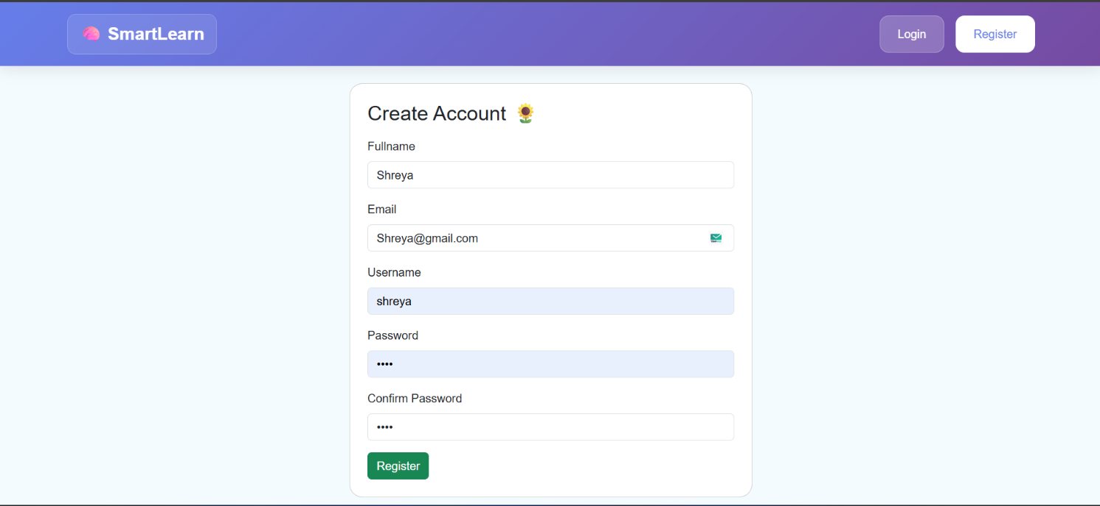

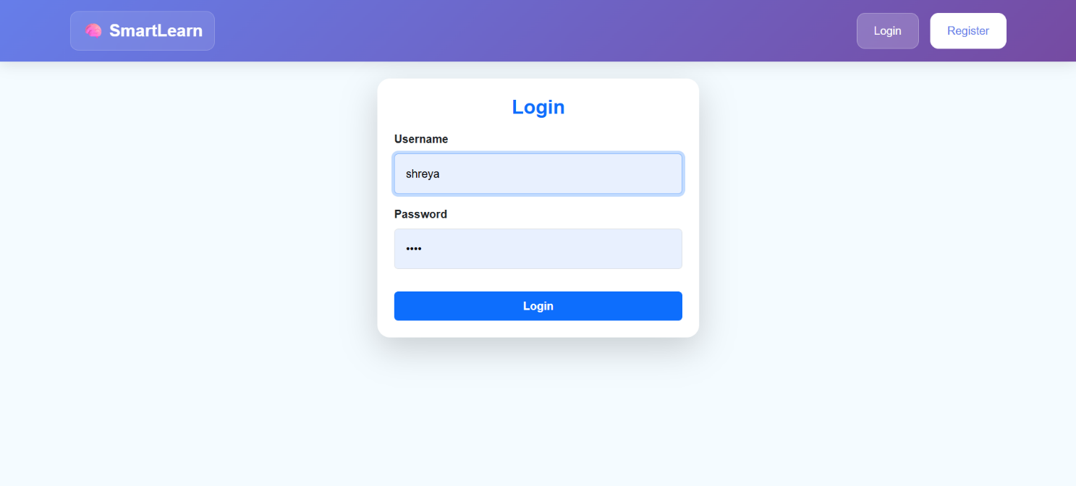

2.Learning Path Module
Displays a set of structured learning activities that guide students step-by-step in improving their reading and language skills.
Each activity is represented with colorful cards, making navigation simple and engaging.
Students can choose from different learning paths such as Phonemic Awareness, Rhyming Patterns, Word Building, Syllable Mastery, Silent Letters, and Rapid Naming.
Each card includes a short description and a “Start” button, helping students easily begin the activity they want to learn.

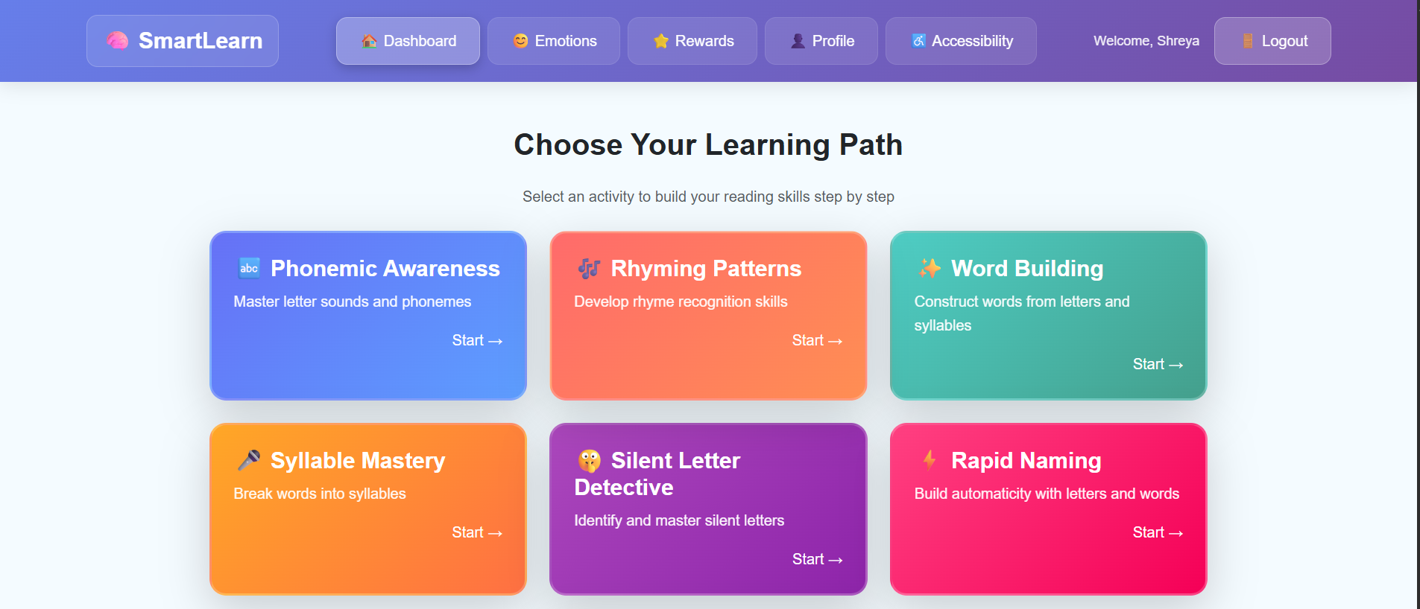

3. Rewards Management Module
Tracks and displays the total stars earned by the student based on their learning activities.
Students can view their overall achievements in a clean and motivating interface.
The module encourages consistent learning by rewarding progress with stars, badges, or milestones.
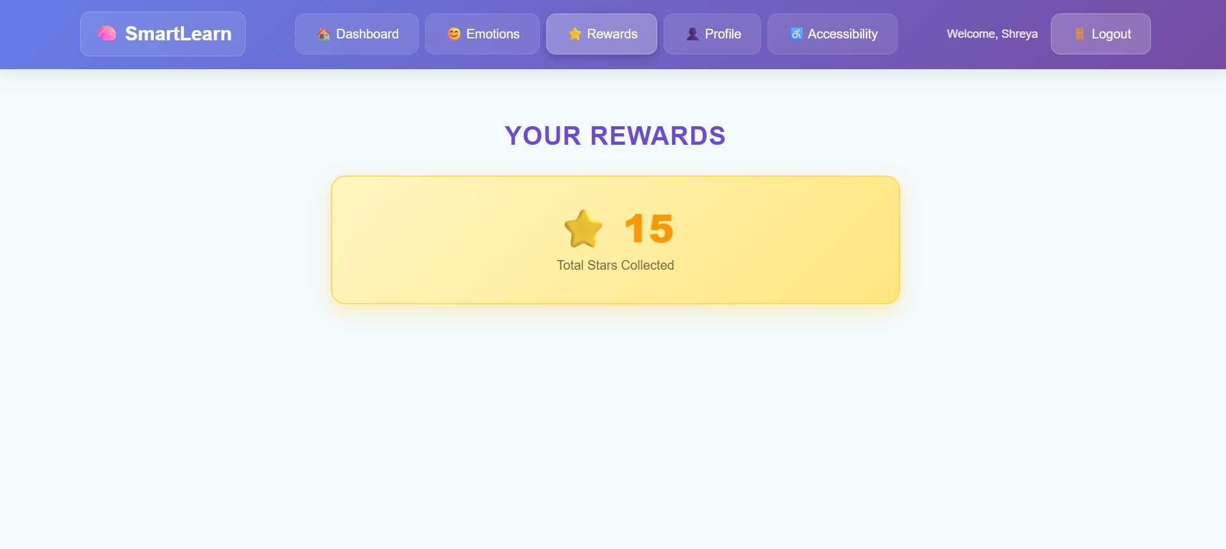

4. profile
Allows students to view and update their personal information such as name, username, and email.
Displays the user’s account details in a clean and organized layout.
Helps students manage their profile securely and keep their information up to date.
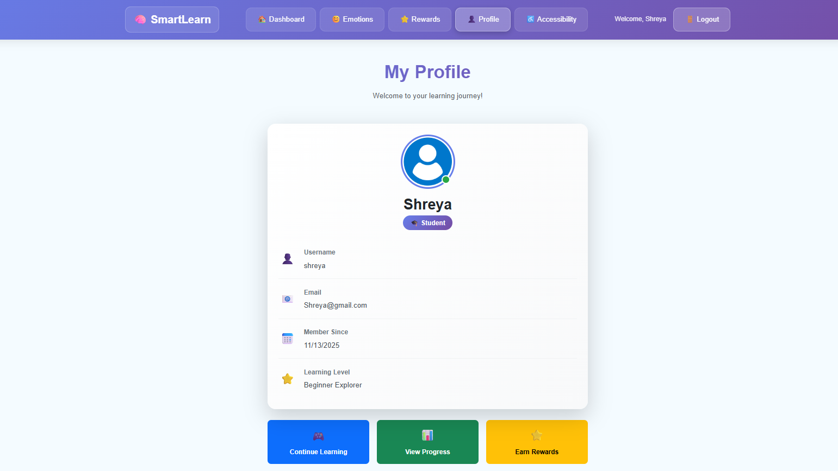

5. Accessibility Settings
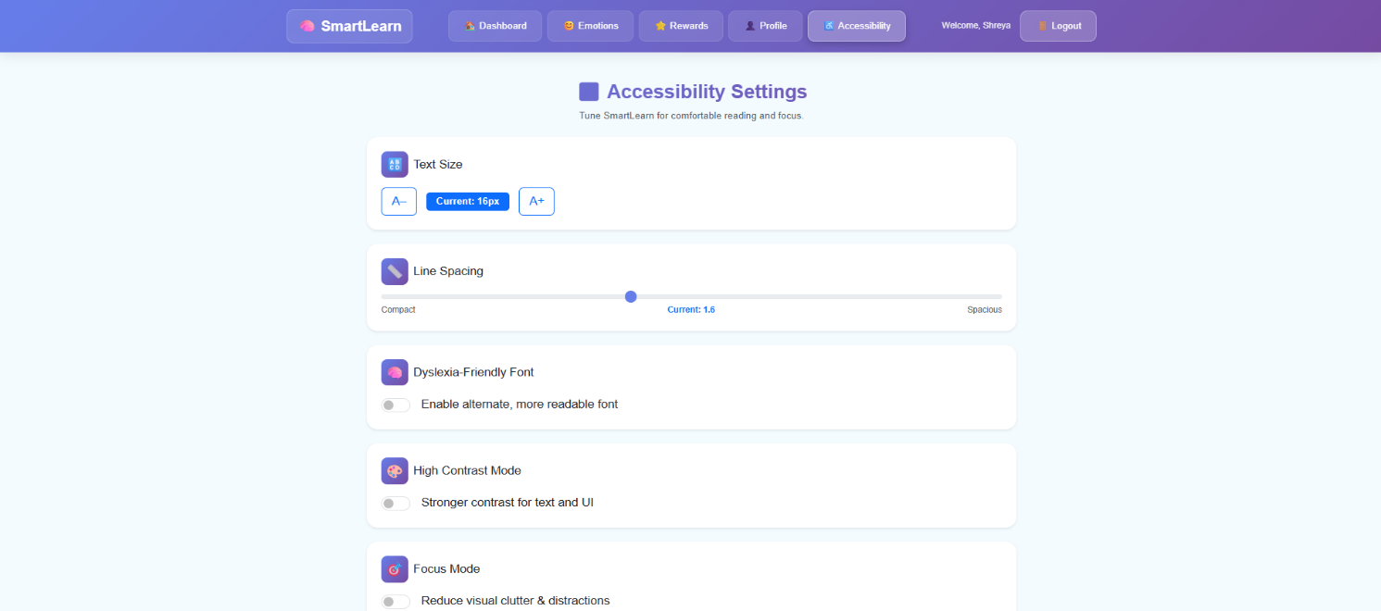
The Accessibility Settings module allows students to enable Dyslexia Mode and adjust text for easier reading.
It helps create an inclusive learning experience by customizing the interface to individual needs.
6. Admin
The Admin module allows administrators to manage users, learning modules, rewards, and system data efficiently.
It provides full control over the platform, ensuring smooth operation and accurate monitoring of student progress.

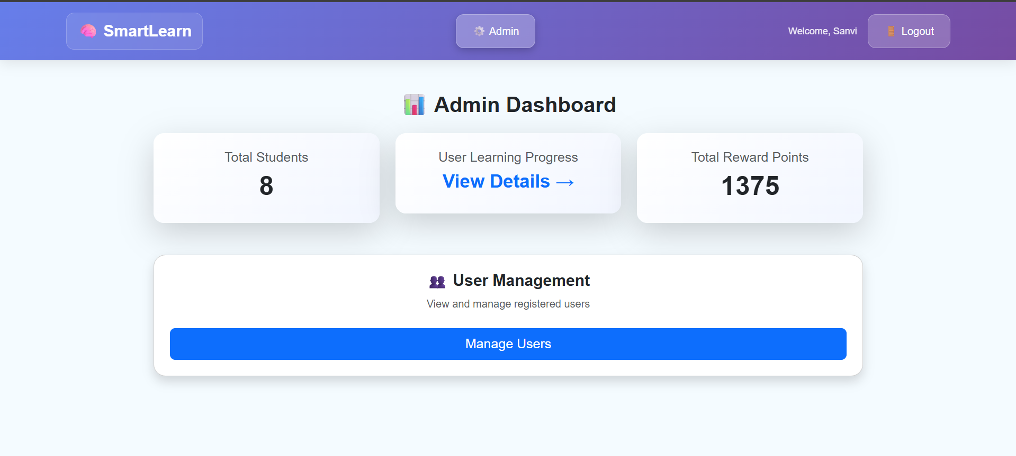
6. User Management
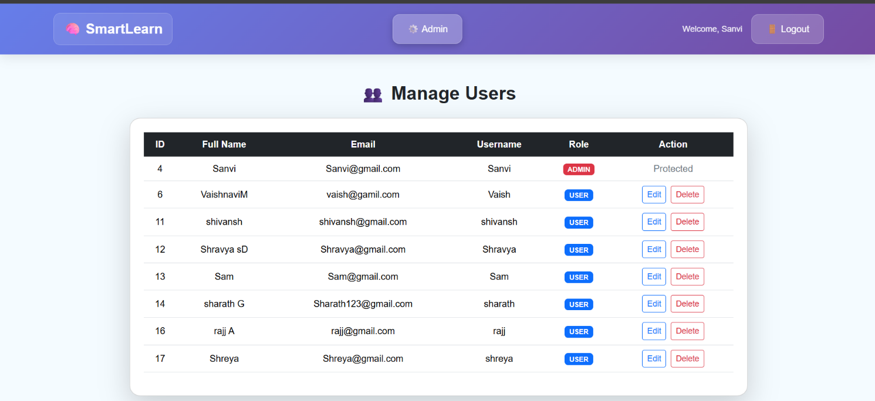
The User Management module allows administrators to efficiently add, update, and organize all user accounts within the SmartLearn system. It provides secure handling of student and admin details, ensures proper access control, and helps maintain a well-structured user database for smooth platform operation.

6. User learning Progress
The User Learning Progress section provides a clear overview of each student’s learning activity. It displays key details such as user ID, full name, username, number of lessons completed, and total reward points earned. This table helps administrators quickly monitor student performance, track engagement levels, and identify learners who may need additional support.
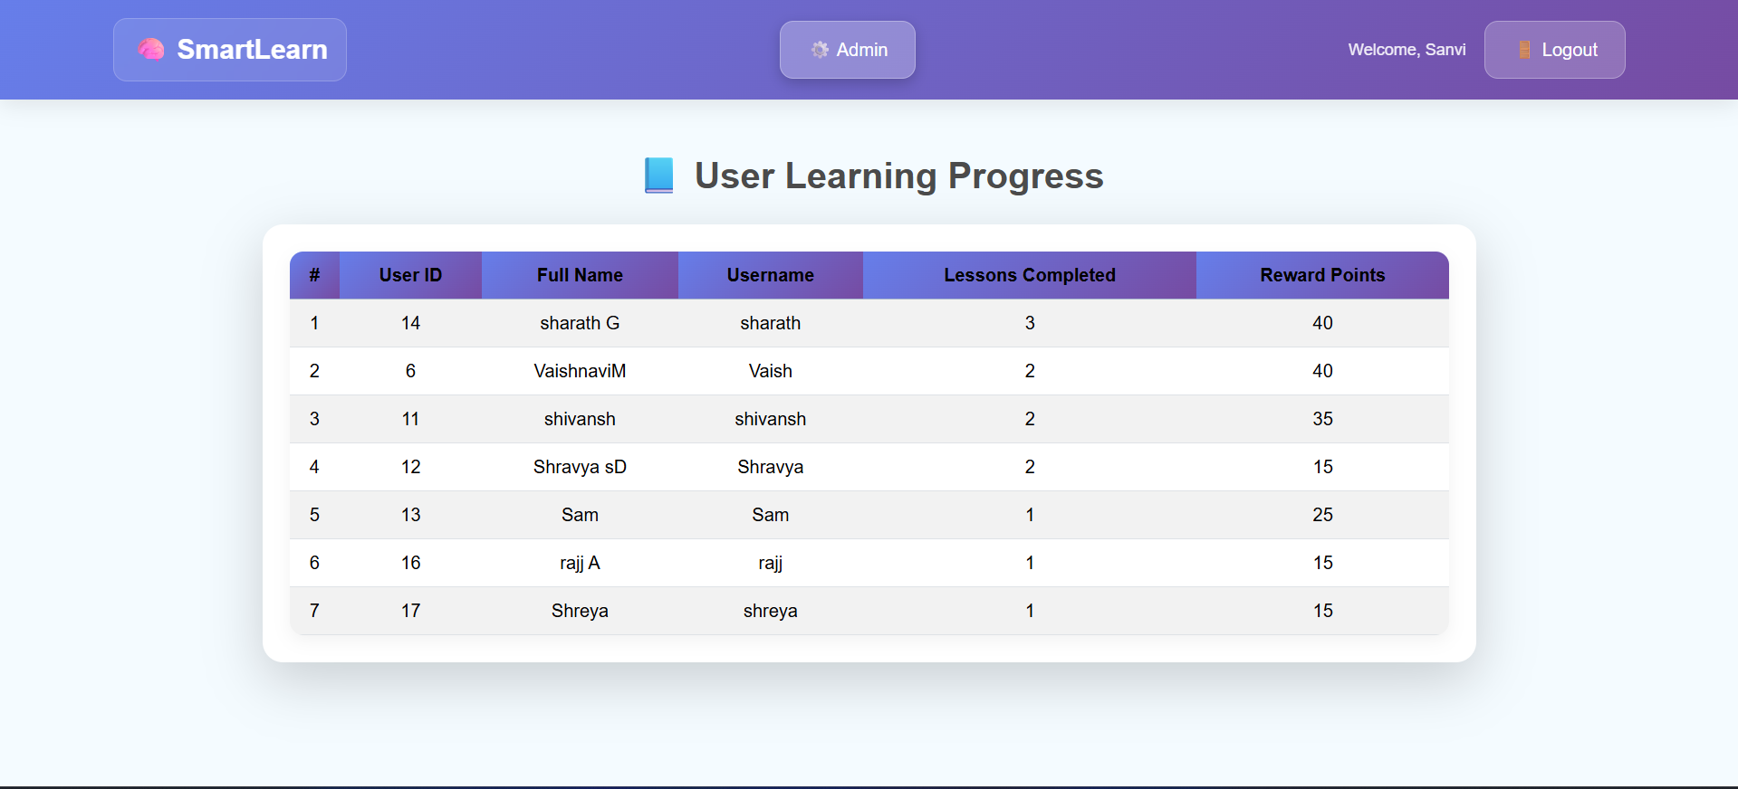

Chapter 8
Future Enhancements
• AI-Based Learning Personalization:
Integrate machine learning models to analyze user emotions, learning speed, module interactions, and progress history. The system can automatically personalize learning paths, recommend suitable activities, and identify students who may need additional cognitive support.
• Automated Progress & Emotion Reports:
Generate detailed reports that include learning progress, emotion trends, reward achievements, and module completion summaries. These reports can be exported as PDF or Excel for students, teachers, and parents to review overall performance.
• Parent/Guardian Monitoring Portal:
Introduce a secure login for parents or guardians to view their child’s learning activity, emotional patterns, progress levels, and earned rewards. This keeps parents informed and involved in the student’s learning journey.
• Real-Time Alerts for Low Engagement:
Send notifications to admins or educators when a student shows low engagement, negative emotional patterns, or decreased activity. This allows timely support and targeted intervention to improve the learner’s experience.
• Learning Paths & Activity Scheduler:
Add tools for scheduling daily learning activities, recommended exercises, and AI-suggested modules. Students receive reminders for upcoming tasks, helping them stay consistent with learning routines.
• Mobile App for SmartLearn:
Develop an Android and iOS version of SmartLearn that syncs with the web platform. Students can access modules, rewards, and emotional insights from anywhere, with real-time notifications.
• In-App Teacher–Student Chat Support:
Include a secure chat system where students can ask doubts, request feedback, and communicate directly with educators. This strengthens support, improves understanding, and enhances overall engagement.

Chapter 9
Conclusion
The development of SmartLearn demonstrates the creation of a modern, intelligent, and inclusive learning platform designed to meet the diverse needs of today’s digital learners. This project showcases how AI-driven educational solutions can transform conventional learning experiences by integrating personalized support, emotional understanding, and accessibility features into one unified system. Through its thoughtful design and interactive modules, SmartLearn bridges the gap between traditional e-learning and adaptive, cognitive-based learning, offering students a more supportive and engaging environment.
Building SmartLearn significantly strengthened my technical abilities across multiple areas of full-stack development. On the frontend, I designed dynamic and user-friendly interfaces using React, focusing on clarity, accessibility, and seamless navigation. On the backend, I implemented secure and efficient REST APIs with Spring Boot, utilized JWT-based authentication for role-specific access, and structured a scalable MySQL database to handle user data, emotions, learning progress, and rewards. The project deepened my understanding of AI integration, system architecture, API communication, user experience design, and state management, enabling me to deliver a comprehensive and robust full-stack application.
Beyond technical development, this project improved my ability to analyze real-world learning challenges faced by students, educators, and neurodiverse users. By studying these challenges, I designed SmartLearn to include essential features such as Dyslexia-Friendly Mode, Emotion Detection, and Gamified Rewards—all aimed at improving student engagement, emotional well-being, and learning outcomes. The platform presents learning progress through intuitive dashboards, visual analytics, and real-time feedback, making complex insights easy to understand and more actionable for students and administrators alike.
SmartLearn successfully enhances the digital learning experience by making it more inclusive, adaptive, and data-driven. Students receive personalized support, teachers benefit from better insights into learner behavior, and administrators can manage and monitor user activity efficiently. The combination of a smooth user interface, intelligent backend processing, and real-time AI-powered insights makes SmartLearn both powerful and easy to use.
Overall, SmartLearn stands as a meaningful and impactful educational platform that highlights my technical, analytical, and problem-solving capabilities. It also opens the door for future enhancements such as deep-learning–based performance prediction, mobile app integration, interactive virtual learning assistants, and advanced emotional analytics. This project marks an important milestone in my journey as a full-stack developer, reflecting my ability to conceptualize, design, and deliver innovative software solutions that add real value to modern learning environments.

